RUNNINGHEAD: CONEY ISLAND 1

Coney Island
Frances Balilo
Molloy College

CONEY ISLAND 2

Coney island is located on the southwestern tip of Brooklyn, New York. Geographically, it was once three small islands comprised of mostly marshes and sand dunes (Good Old Coney Island, 21). It was then turned into a peninsula after planners decided to unite the island to the mainland by landfill (BG, 492).
Originally Coney Island was inhabited by the Lenape Native Americans, naming the island “Narrrioch” which translated to the land of no shadows because of the amount of sun the beach received. When Henry Hudson and the Dutch discovered and occupied this land in 1609, they later renamed it Konijin Eiland after all the rabbits that inhabited the land. The name Coney Island later became an adaptation to the original Dutch name (Good Old Coney Island, 21).
The five-mile stretch of desolate barren land began its transformation as new carriage roads and steamships began to populate the area, helping bring in business to the area. The successfulness of Coney Island is most accredited to this technological advancement, shortening travel time from as long as half a day to as little as two hours (Good Old Coney Island). During the early 1830’s and 1840’s Manhattan was where most New Yorkers settled, making it one of the most populated areas in the world at the time. With thousands of New Yorkers seeking to take a pause from their city lives, Coney Island became a primary escape destination because of it close proximity to Manhattan (Coney Island, 15). The rise of hotel and inns to help accommodate the influx of vacationing tourist also boost commerce.
Coney Islands golden days occurred at the turn of the early 20th century when three amusement parks were developed to provide limitless entertainment and recreation
CONEY ISLAND 3

for those seeking for thrill and excitement. In 1897, Steeplechase Park opened providing rambunctious entertainment. It was legendary for its Steeplechase ride, the infamous Blowhole Theater (an open space where its floors blew out air, often raising the skirts/dresses of unsuspecting women), rollercoasters, large ballrooms, and the countries largest swimming pool measuring 270 feet by 90 feet (Coney Island 42). It later closed in 1964 due to declining business.
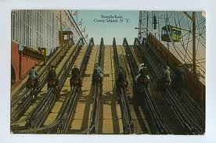
Steeplechase Ride (Coney Island, 38)
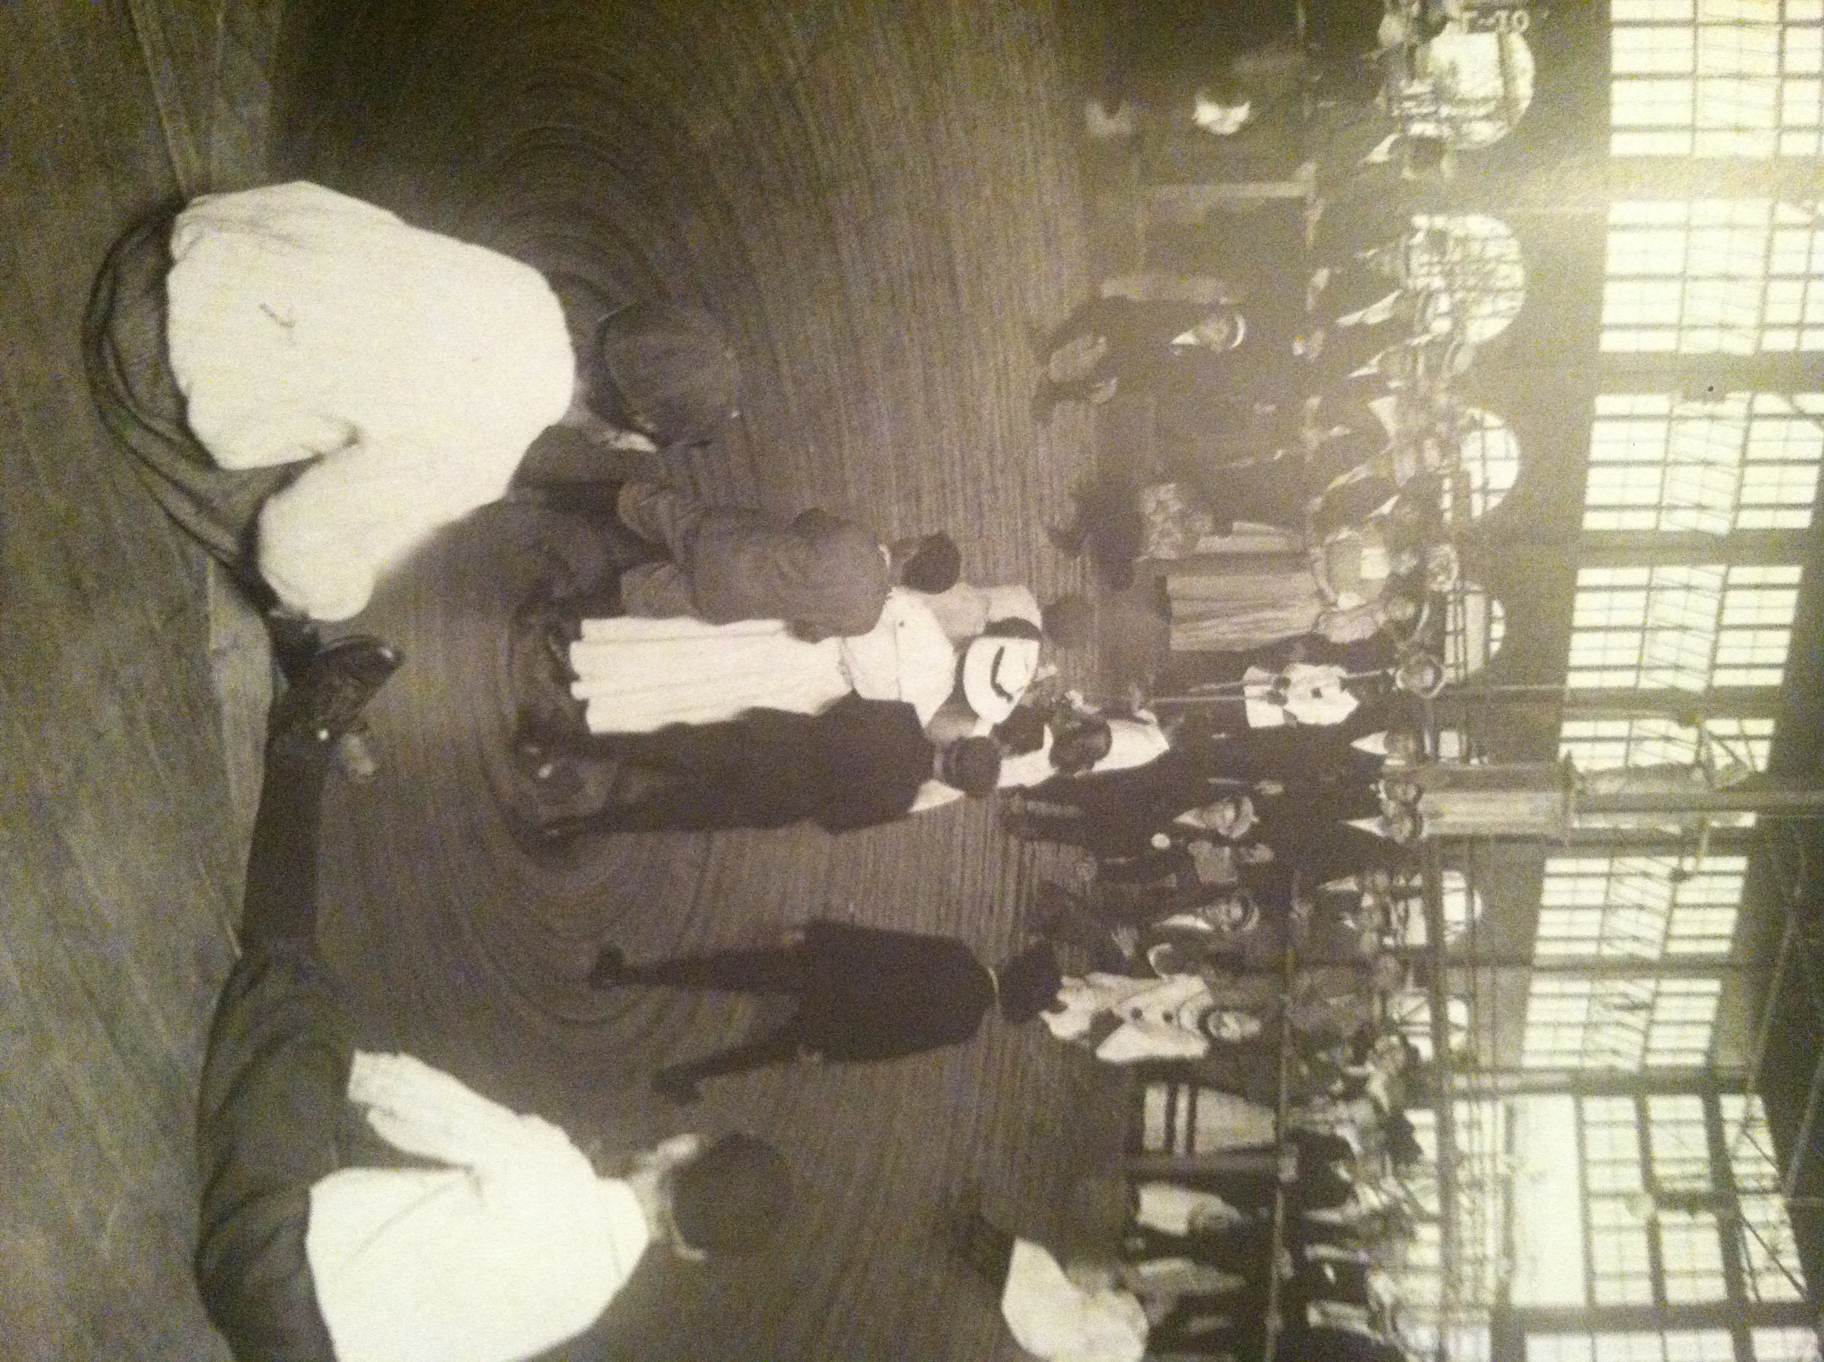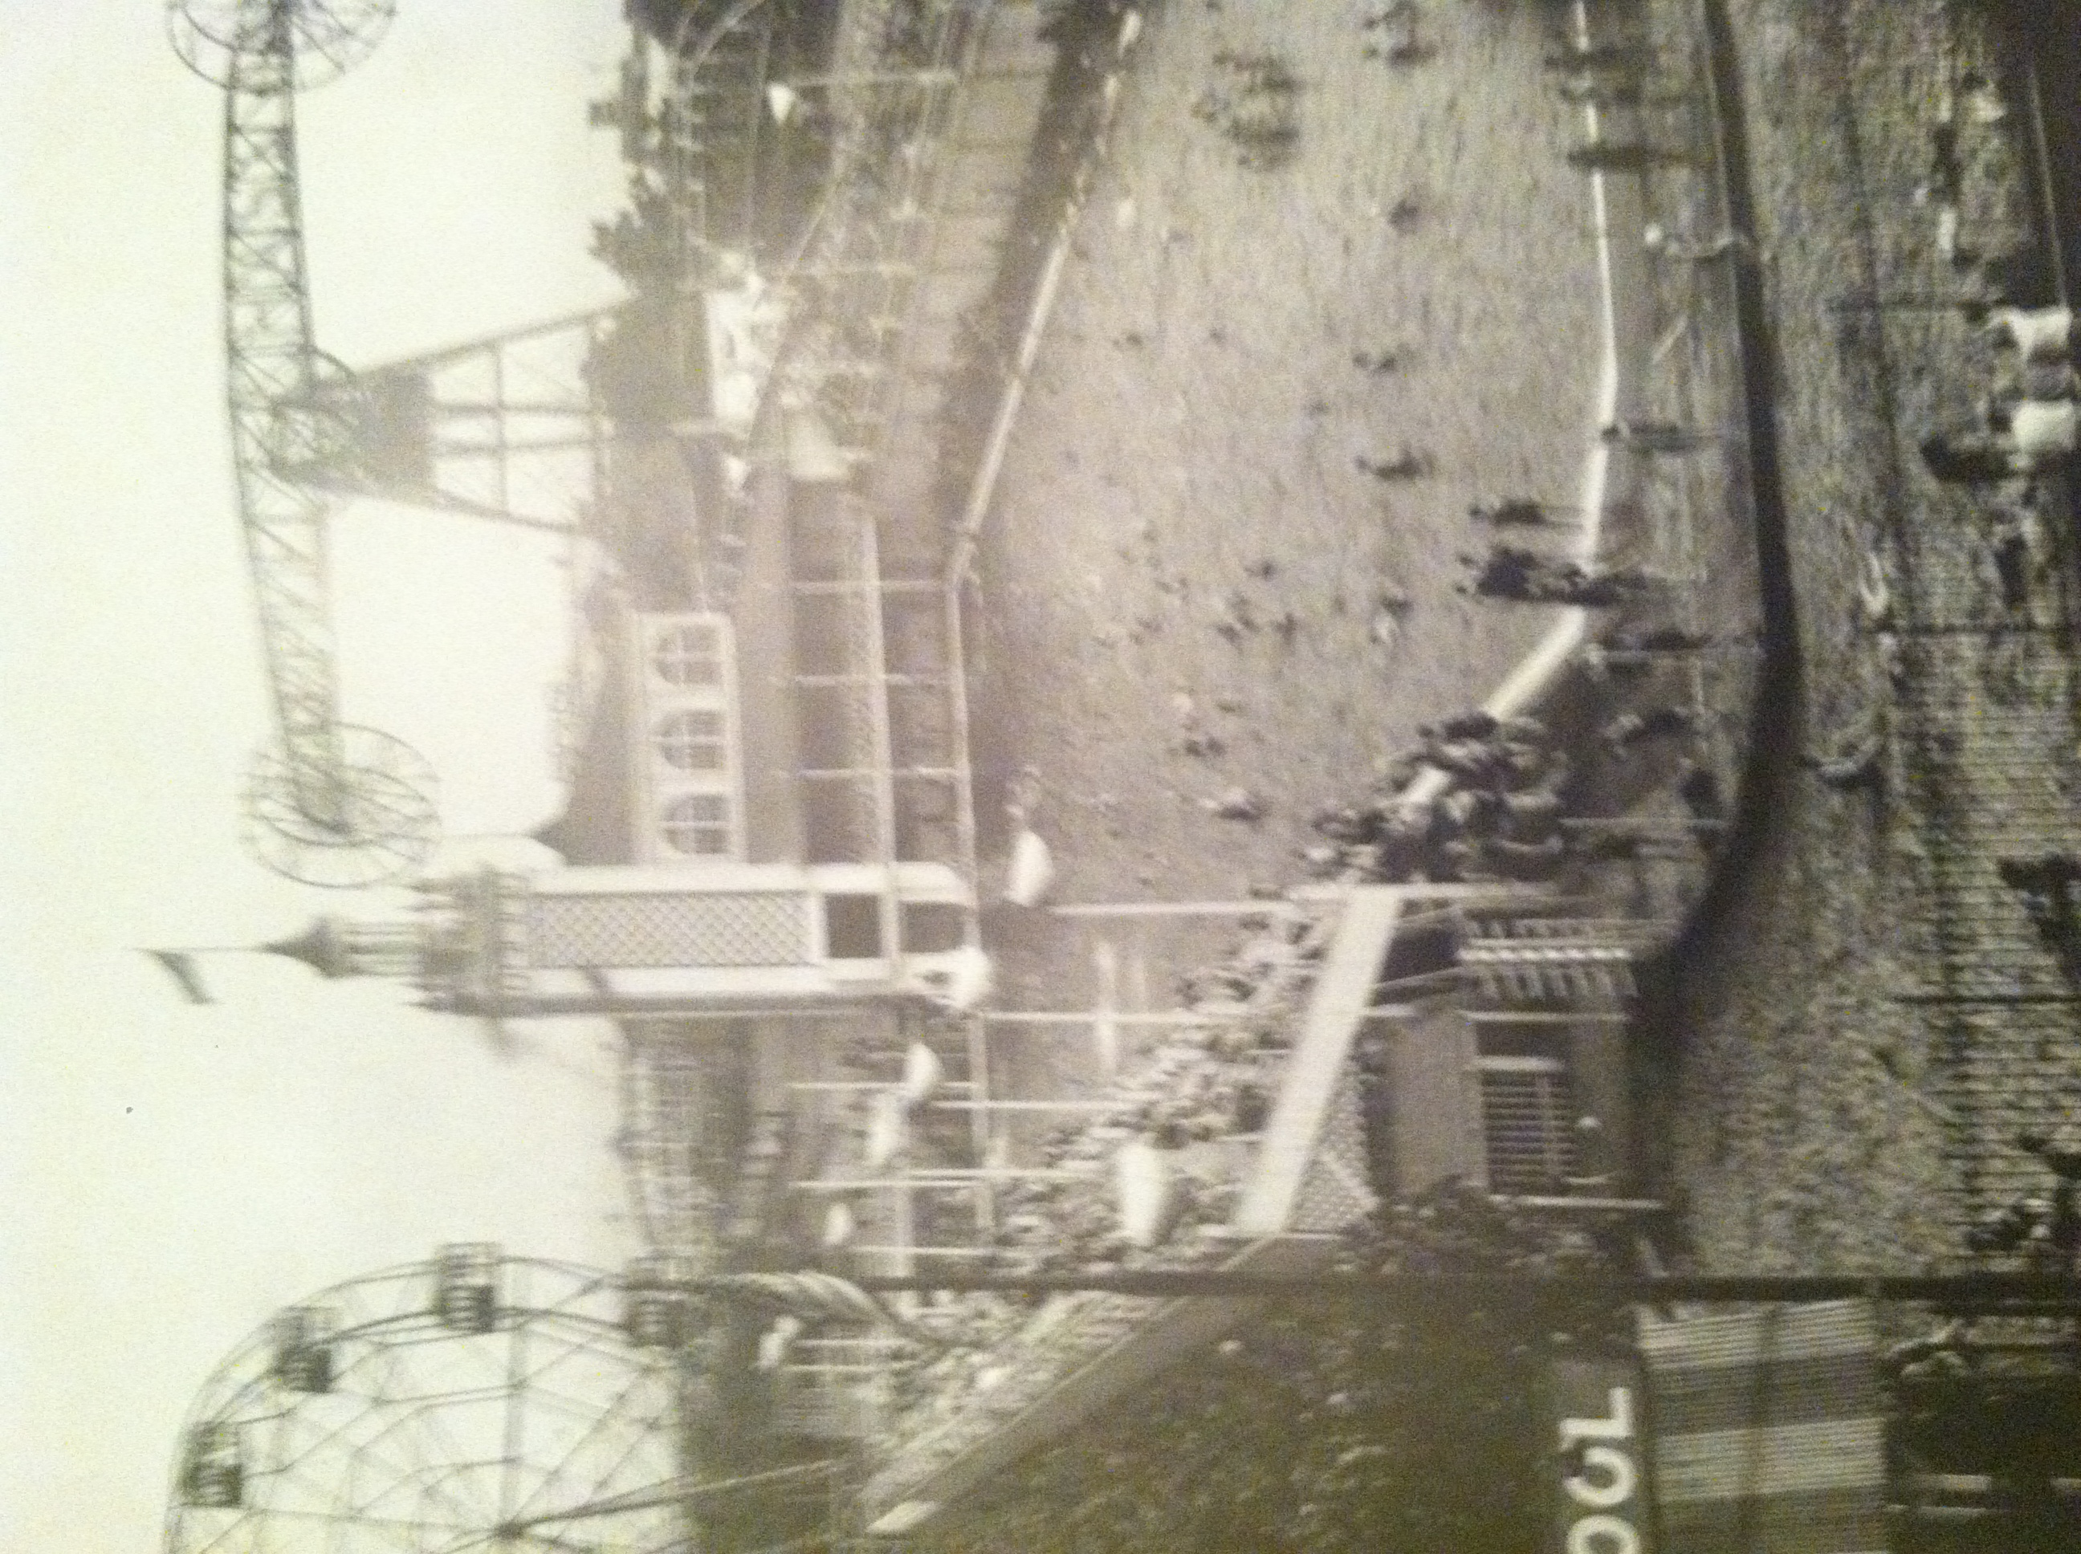
Blow Theater (Coney Island,41) Left

Swimming Pool (Coney Island, 42) Right
CONEY ISLAND 4
In 1903 Luna Park opened, followed by Dreamland opening just a year after (1904). Both parks struggled to compete with each other, consistently trying to outdo the other. One example would be the battle of creating a larger version of Shooting the Chutes ride. Dreamland outdid its rival by calling their ride Shoot the Chutes; built to be the largest water slide ever see at the time at 280 feet. Luna Park was known for the millions of lights that adorned the structures, creating visually appealing sceneries. Unfortunately, years apart, both Luna Park and Dreamland burned down in fires.

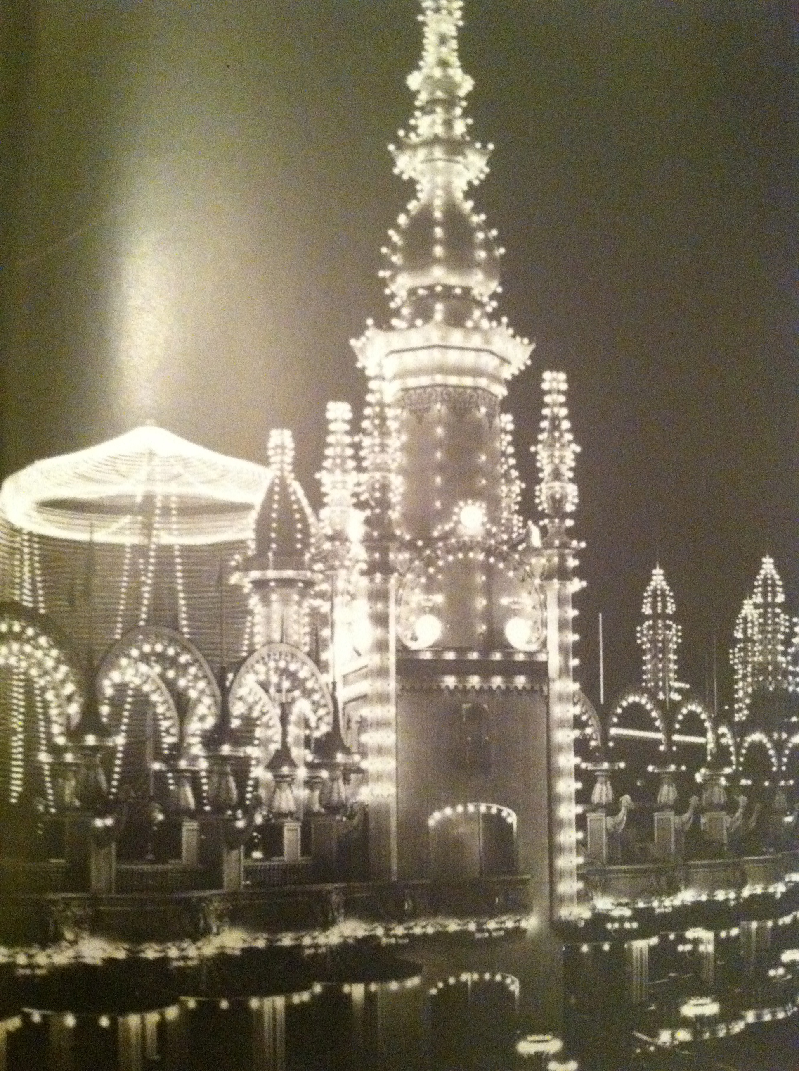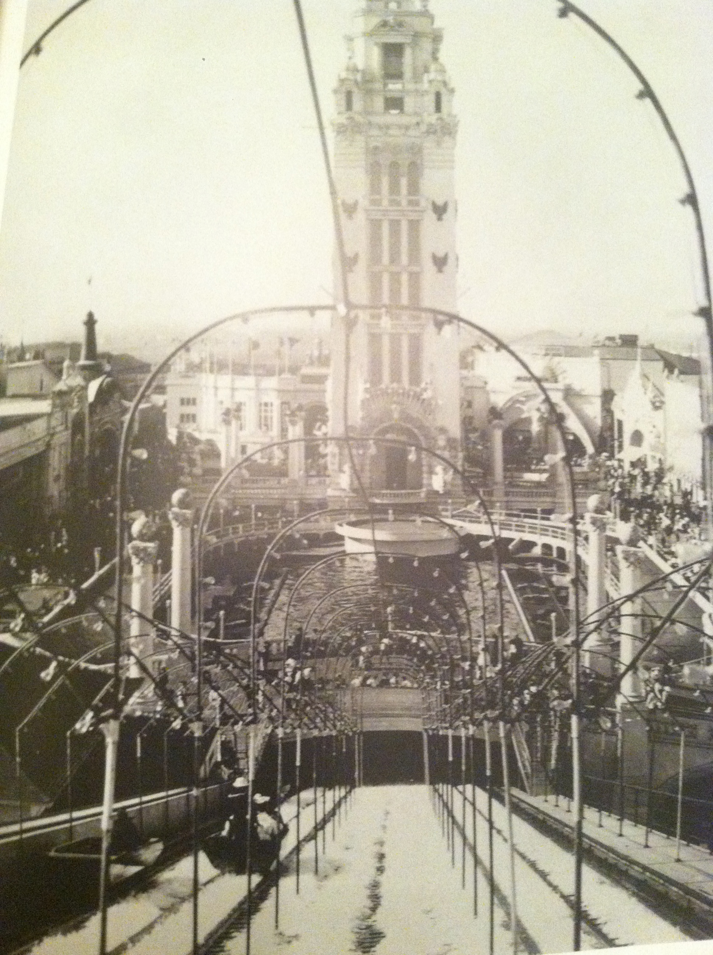
Luna Park Incandescent lights (Coney Island, 47) Left
Dreamland “Shoot the Chutes” ride (Coney Island, 37) Right

CONEY ISLAND 5

Over the past several decades after the closing of the last amusement park (Steeplechase park), commercial and housing units began to appear. An uproar to conserve, preserve and maintain the space as a recreational area became priority. Robert Moses rezoned areas of the island in efforts to reclaim the beach, however felt indifferent to the “hostile and cheap” amusements the park brought- making sure that city funds did not help maintain the region (Coney Island, 107). Ultimately, the city decided that the land south of Surf Avenue would be guarded as a natural city park. Any structures that covered the entrance to the park would be dismantled to regain access to the beach. Coney Island’s landscape since then has been going through negligent change. The further development/construction of parks and beaches by Robert Moses further east of Coney Island in the 1940’s resulted in the inevitable decline of popularity of the park. Federally funded urban renewal or “urban removal” housing projects emerged in Coney Island, where Elderly blacks and Latino’s predominantly resided in the area. Sadly, by the early 1960’s gang violence began to encompass the neighborhood further deteriorating the once vivacious and cheerful spirits the area produced (Coney Island, 107).
Destructive flames in the 1932 fires destroyed 178 building and left one thousand people homeless. An ill prepared fire department and lack of fire hydrants led to most of Coney Islands demise (Coney Island, 104).

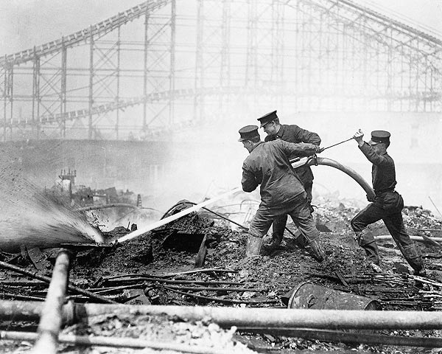
CONEY ISLAND 6
Even with the unfortunate closing and destruction of Steeplechase Park, Luna Park, and Dreamland, several remnants of Coney Island heyday fortunately live on. Currently, New York has landmarked three of the parks biggest attractions: Parachute jump (closed off in 1968), The Wonder Wheel, and The Cyclone roller coater (New York Year by Year, 304). Nathan Handwerker who was famed for his invention of the Nathan hotdog, first concession stand can also still be seen standing proud on the corner of Surf and Stillwell Avenue (Coney Island, 13). At the start of the twenty-first century, plans to renovate Coney Island began. New Yorkers began to rediscover and appreciate the history that once came with the park.
As the future of Coney Island is questionable, thrill seekers still take a piece of history every time they tread through the amusement park, boardwalk, and its sandy shore. Coney Island will forever be known as a place of laughter, leisure, and amusement as future generations continue to explore one of NewYork’s gems.

Works Cited
Berman, John S. Coney Island. New York: Barnes & Nobles Publishing, 2003. Print.
Krosessler, Jeffery A. New York Year by Year. New york: New York University Press, 2002. Print.
McCoullough, Edo. Good Old Coney Island: A Sentimental Journey Into the Past. New York: Fordham University Press, 2000. Print.
Pressentin Wright, Carol Von, et al. Blue Guide. New York: Blue guides Limited, 2008. Print.

